**Restaurant Sales Analysis by MySQL**

**Project Overview:**

This project uses SQL to analyse customer orders and menu item details from a restaurant

database. The goal is to extract valuable insights such as most popular items, sales performance, and spending behaviour to help the restaurant improve decision-making.

**Data:**

Imported a csv file (restaurant_db) and loaded in MySQL Workbench.

**Tables Used:**

Menu_items: Contains details of food items including price and category

Order_details: Contains order-wise item purchases by customers

**Key SQL Tasks Performed:**

**Data Joining:**

* Combined order_details and menu_items using LEFT JOIN on item_id to create a unified dataset for analysis.

**Item Popularity:**

* Identified **most and least ordered items**
* Analysed **item categories** (e.g., appetizers, mains, desserts)

**Spending Analysis:**

* Found the **top 5 orders** with the highest total spend
* Calculated **average spends per order**

**Category Performance:**

* Summarized **sales revenue** by food category
* Highlighted which categories contribute most to income

**Menu Insights:**

* Suggested **best-selling items**
* Detected **underperforming items** possibly for removal

**MySQL Workbench (Questions & Answers):**

**Menu_items:**

1. Display menu items table.

Query:

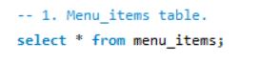

Result:

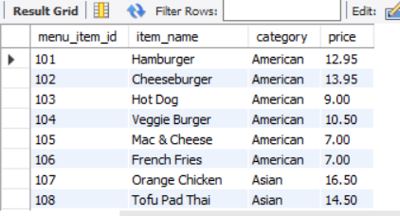

1. Display the number of items on the menu.

Query:



Result:

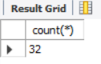

1. What is most and least expensive items on the menu table?

Query:

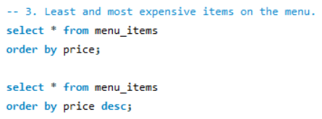

Result:

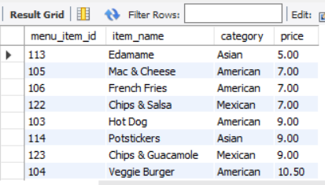

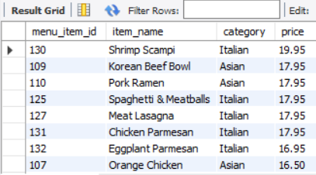

1. Display the number of Italian dishes on the menu.

Query:

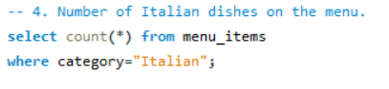

Result:

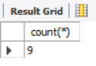

1. What is the least and most expensive Italian dishes on the menu?

Query:

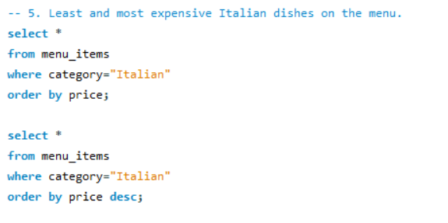

Result:

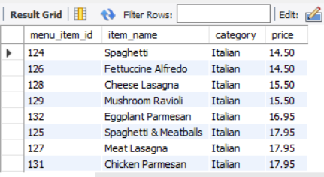

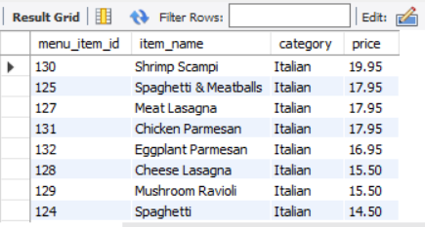

1. Display the number of dishes in each category.

Query:

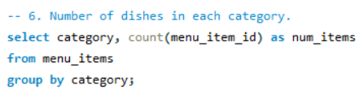

Result:

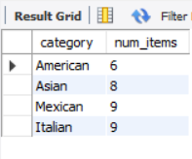

1. What is the average dish price within each category?

Query:

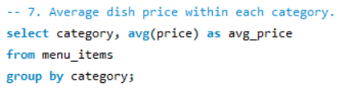

Result:

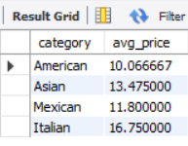

**Order_details:**

* 1. Display the order details table.

Query:

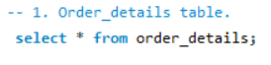

Result:

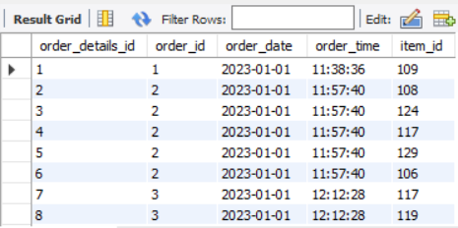

* 1. Display the date range of the table.

Query:

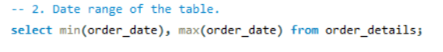

Result:

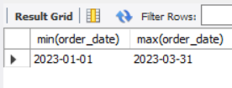

* 1. Display the number of orders made within this date range.

Query:

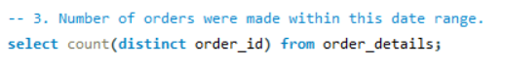

Result:

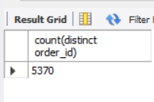

* 1. Display the number of items were ordered within this date range.

Query:

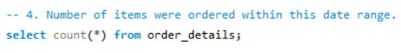

Result:

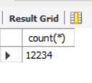

* 1. Display the orders having most number of items.

Query:

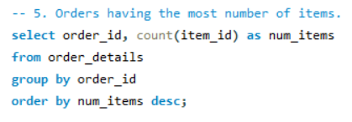

Result:

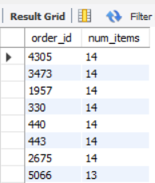

* 1. Display the number of orders had more than 12 items.

Query:

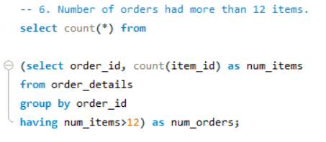

Result:

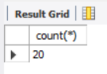

**Restaurant Analysis:**

* 1. Combine the menu_items and order_details table into a single table.

Query:

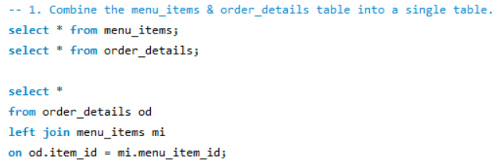

Result:

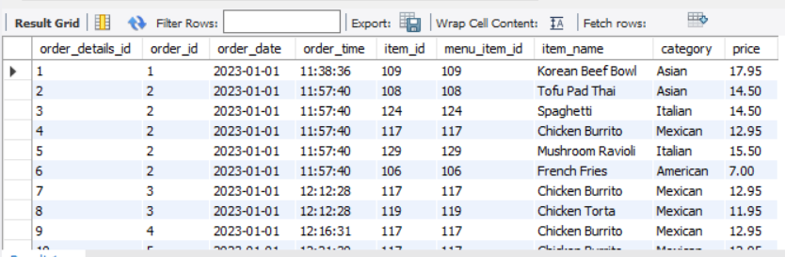

* 1. What were the least and most ordered items? What category were they in?

Query:

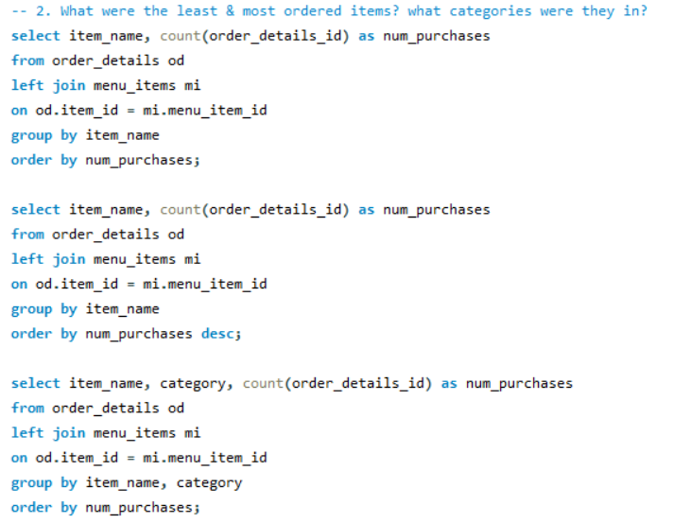

Result:

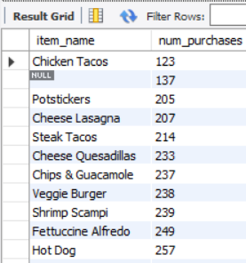 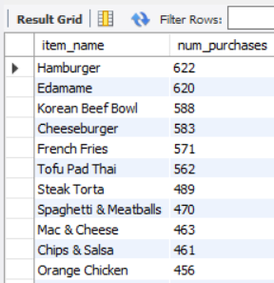

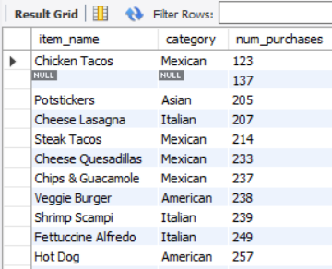

* 1. What were the top 5 orders that spent the most money?

Query:

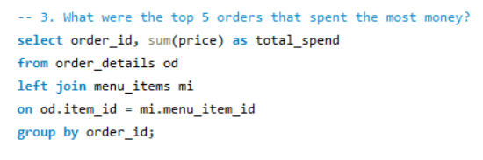

Result:

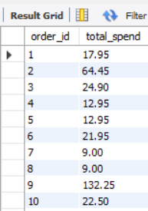

* 1. View the details of the highest spend orders. What insights can you gather from this?

Query:

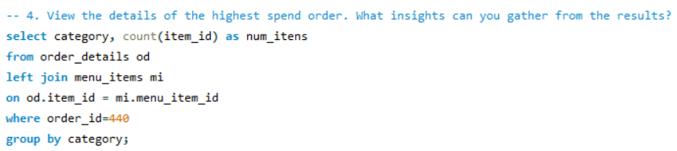

Result:

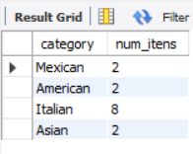

* 1. View the details of the top 5 highest spend orders. What insights can you gather from this?

Query:

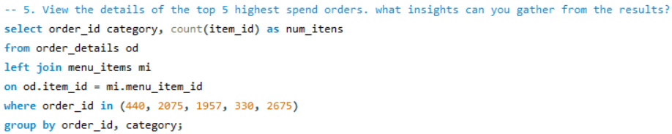

Result:

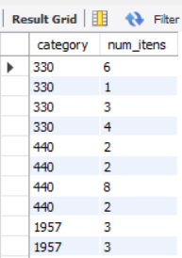

**Conclusion:**

The analysis revealed that:

* Certain items significantly outsell others, indicating strong customer preference.
* A small number of high-value orders contribute a large portion of revenue.
* Some food categories consistently generate higher sales, providing direction for menu focus.

This SQL-based project helps restaurant management understand customer behavior, optimize the menu, and improve profitability through data-driven decisions.